AWS Cloud Quest  
**Task 8. First NoSQL Database**

Use Amazon DynamoDB to create a NoSQL database that helps to track customer viewing data, such as movies watched and device type, from metadata.

|  |  |
| --- | --- |
| Person | Hi welcome to the best entertainment streaming service in the city. Thanks for answering the call. |
| Me | No worries. How can I help you? |
| Person | We want to add more features to our streaming services, which would require a highly scalable database with lightning-fast performance.  One feature idea we have is to add a digital bookmark so that customers can continue watching shows where they left off. Can we accomplish this without having a well-defined scheme? |
| Me | That would be a nice feature to add. Based on what you have described, I think Amazon DynamoDB is the best option.  Using DynamoDB, you can create NoSQL database, so you don’t have to worry about a schema. The database automatically scales and has single digit millisecond latency. |
| Person | Okay that might work. But what about gathering metadata on viewing habits from customer devices? Can a NoSQL database organize a large number of metadata, and the storage of it? |
| Me | It sure can! DynamoDB supports petabytes of data. And to support your metadata needs, you can add records with unique IDs that have varying attributes. |
| Person | Nice! this sounds like it will greatly enhance our customer’s streaming experience.  Can you help us to implement this solution? |
| Me | Accepted! |
| Person | Fantastic! Let’s go this show on this road. |

**Learning Objectives**

* Create an Amazon DynamoDB table.
* Create a DynamoDB record with metadata attributes.

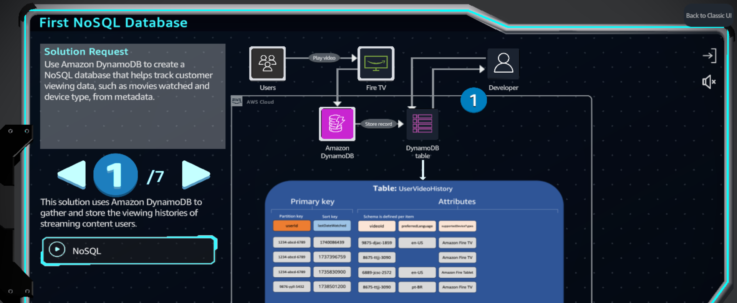

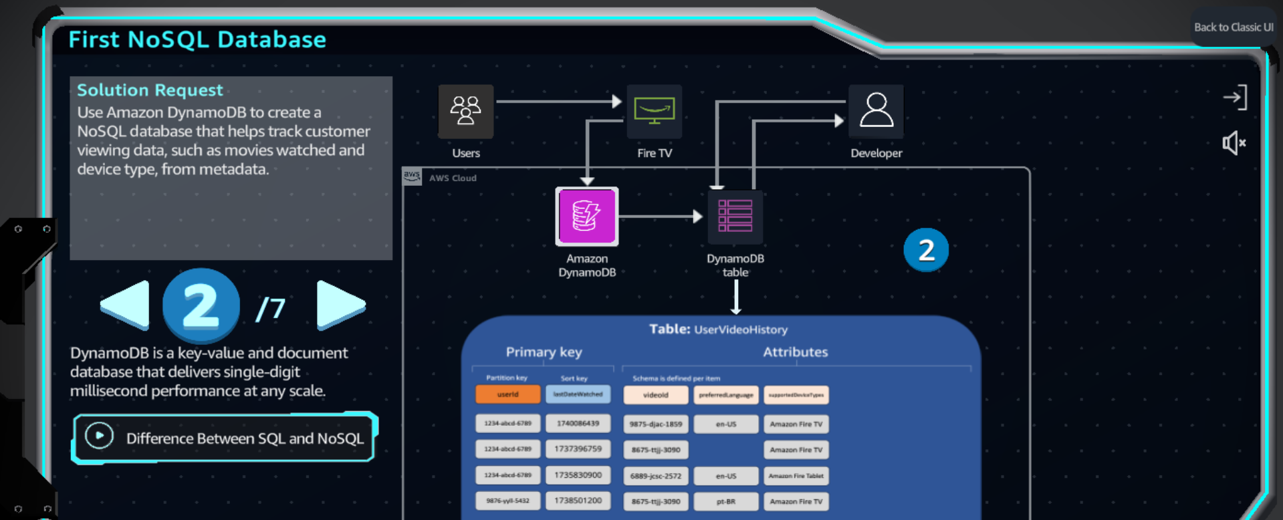

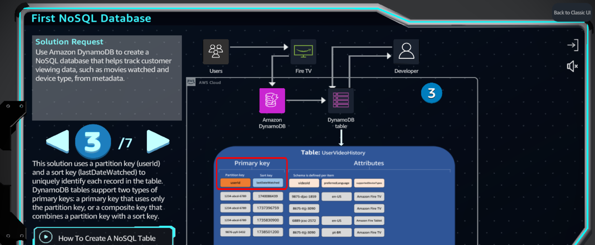

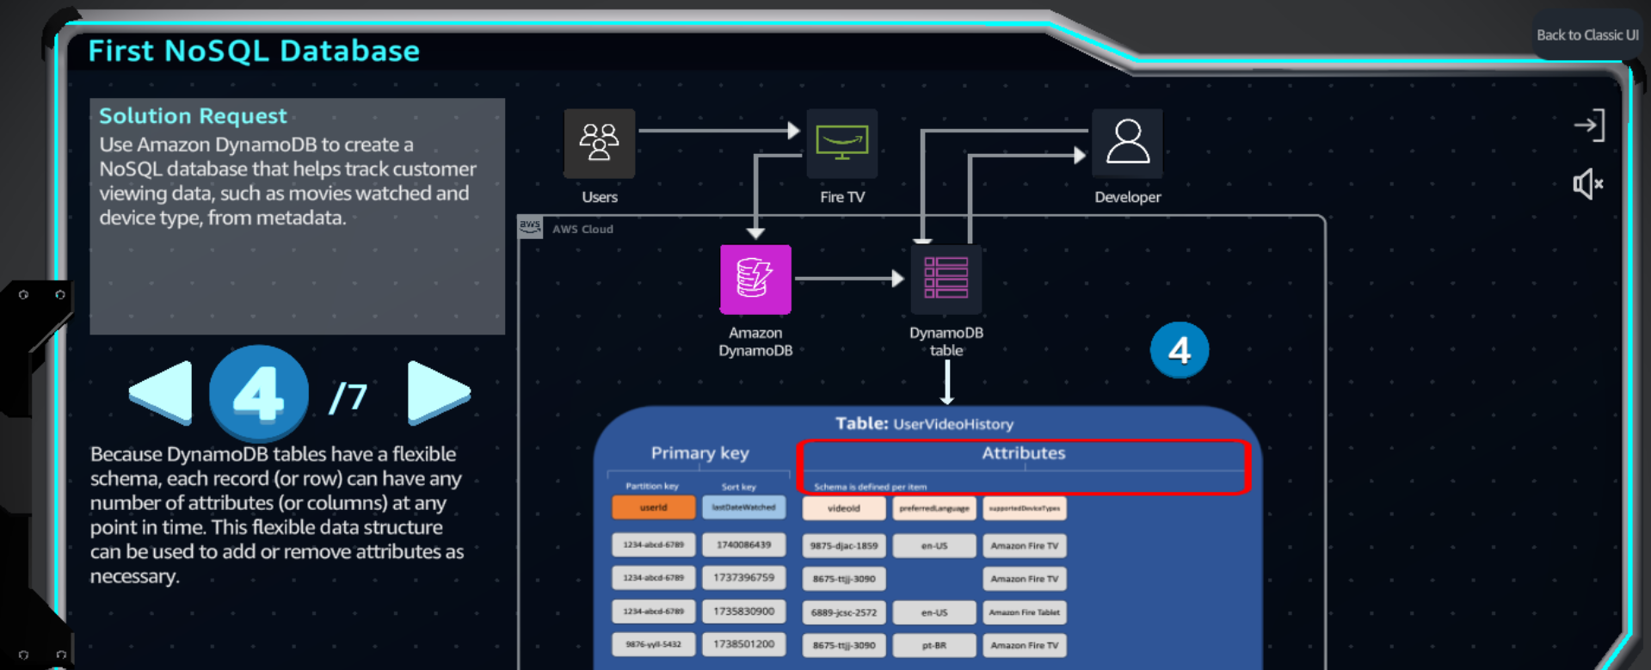

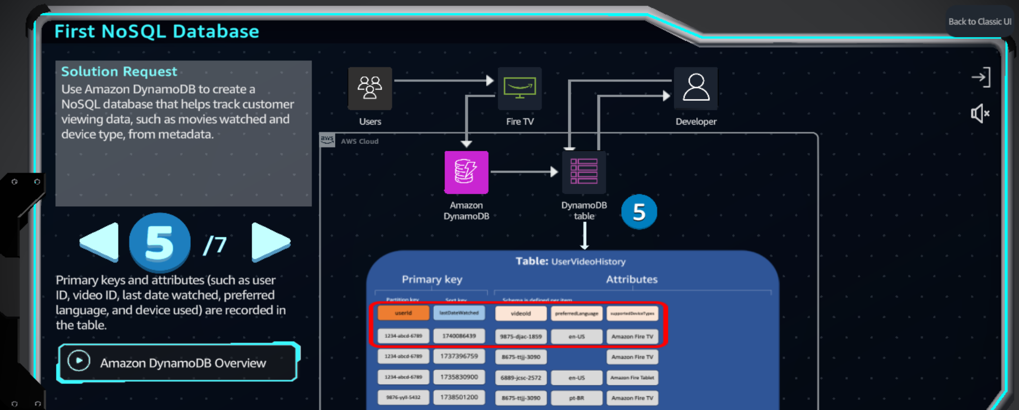

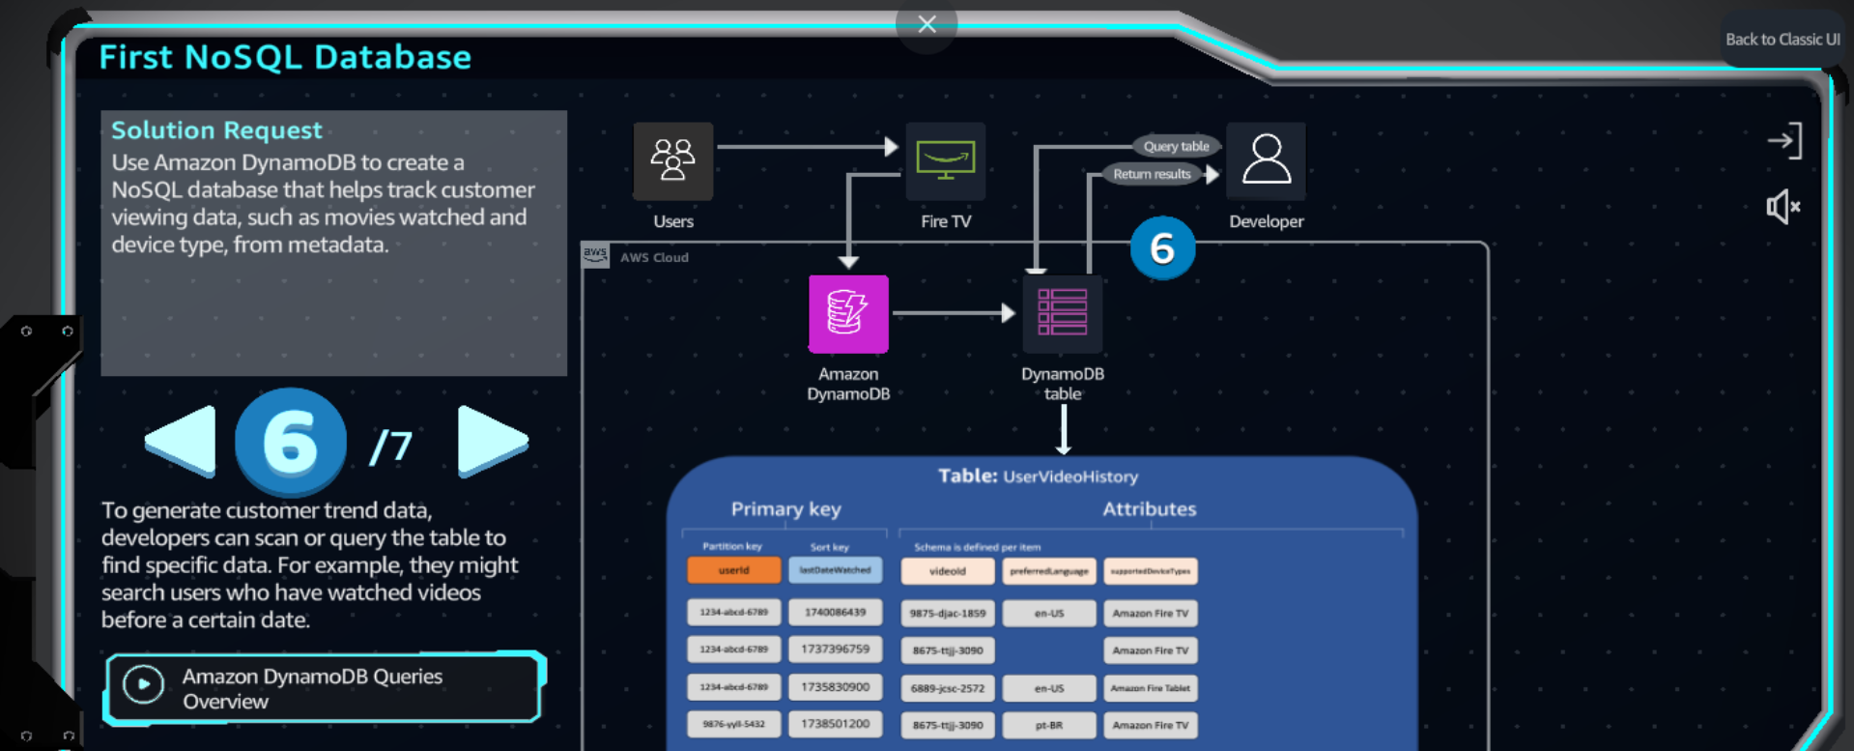

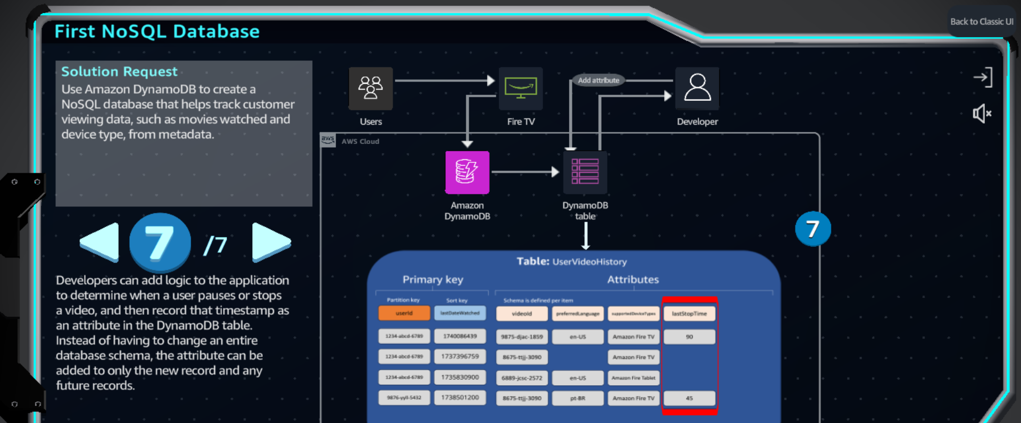

**Practice**

